H.T No
Regulations:
A18

Sreenidhi Institute of Science and Technology
(An Autonomous Institution)
Code No: 7AC02 Date: 06-July-2021 (FN)

B.Tech I-Year I- Semester External Examination, July-2021 (Supplementary)
NETWORK ANALYSIS (ECE)

Time: 3 Hours Max.Marks:70

Note: a) No additional answer sheets will be provided.
b) All sub-parts of a question must be answered at one place only, otherwise it will not be valued.
c) Missing data can be assumed suitably.

ANSWER ANY 5 OUT OF 8 QUESTIONS. EACH QUESTION CARRIES 14 MARKS.

Bloom's Cognitive Levels of Learning (BCLL)

Remember | L1 | Apply | L3 | Evaluate | L5
Understand | L2 | Analyze | L4 | Create | L6

 |  |  | BCLL | CO(s) | Marks
1. | a) | In the network shown below, find the current flowing in 2Ω resistor by using super-node analysis.  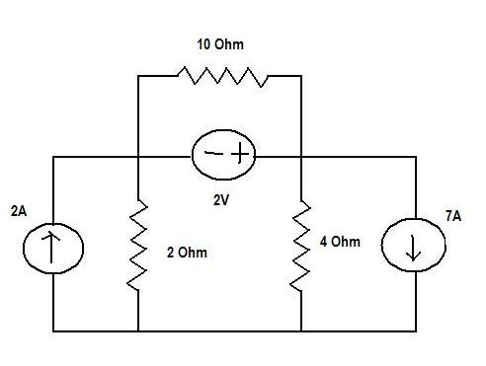 | L3 | CO1 | [7M]
 | b) | Explain the voltage and current relationship of an inductor connected to square wave input. | L2 | CO1 | [7M]
2. |  | Find the average, RMS value and form factor of the waveform shown below.  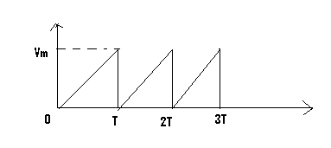 | L3 | CO2 | [14M]
3. | a) | For the three coupled coil shown in below Fig. determine the total Inductance.  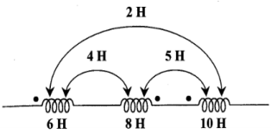 | L3 | CO3 | [7M]
 | b) | Find the equivalent inductance when the coupled coils are connected in parallel opposing mode. | L3 | CO3 | [7M]
4. | a) | In the figure shown below. Find the maximum power delivered to R_{L}  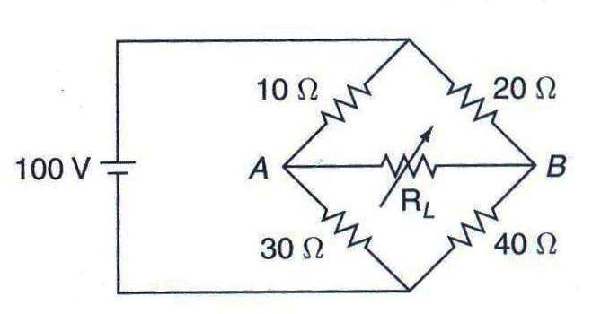 | L3 | CO4 | [7M]
 | b) | Using compensation theorem, find the change in current in 1Ω resistor when 1Ω resistor is changed to 4Ω resistor.  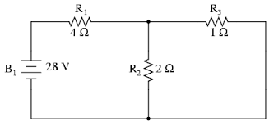 | L3 | CO4 | [7M]
5. | a) | Explain h-parameters in two port network. | L4 | CO5 | [7M]
 | b) | The Z-parameters of a two network are Z₁₁=15, Z₂₂=24 and Z₁₂=Z₂₁=6. Determine ABCD parameters. | L4 | CO5 | [7M]
6. | a) | Write short notes on Transient response of R-L circuit with DC excitations. | L1 | CO6 | [7M]
 | b) | Explain the transient response of series RLC circuit for sinusoidal excitation. | L2 | CO6 | [7M]
7. | a) | A current waveform flowing through an inductor of 1mH is shown in the figure. Obtain and sketch the waveform of voltage across the inductor.  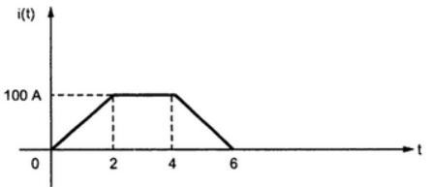 | L3 | CO1 | [7M]
 | b) | Write mesh equations for the network shown below figure.  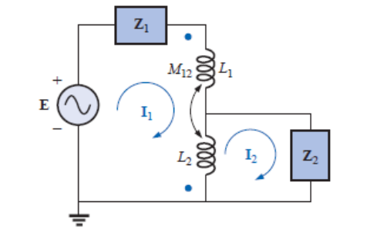 | L3 | CO1 | [7M]
8. | a) | Explain the concept of parallel resonance. | L2 | CO2 | [7M]
 | b) | State and explain the Norton's theorem. | L1 | CO4 | [7M]

-- 00 -- 00 –

